Database introduction

Below is our Entity Relationship Diagram:

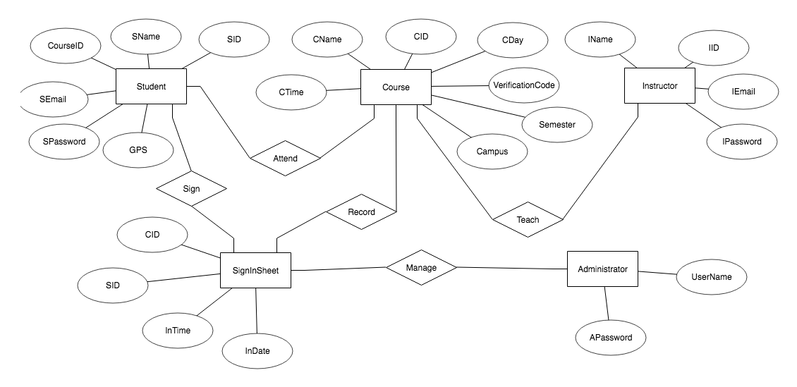

As you can see there are five entities in the ER diagram which includes Student, Course, Instructor, Sign in Sheet and Administrator.

The here is how the relation between our tables looks like:

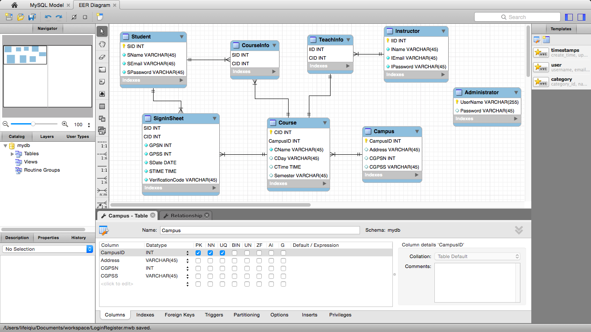

**Administrator**:

This table is used to check admin login and manage the sign in sheet if needed. It has two attributes which are id and passward. And it has no relation with other tables.

**Student:**

This table holds students’ information which includes SName, SEmail, SPassword and SID which is refer to the SID in CourseInfo and the SID in SignSheet. The cardinality between Student and CourseInfo is 1 to many.

**CourseInfo:**

This table is a conjunction table between Student and Course, it has CID and SID and CID is refer to the CID in Course.

**TeachInfo:** This table is a conjunction table between Course and Instructor, it has IID and CID and IID is refer to the IID in Instructor.

**Instructor:** This table holds IID, IName, IEmail and IPassword. The Cardinality is 1 to many. IID is referring to the IID in TeachInfo.

**SignInSheet:** This table holds SID, CID, GPSN, GPSS, SDate, STIME, and VerificationCode.

**Course:** This table holds CID, CampusID, CName, CDay, CTime, and Semester. The CID is referring to the CID in SignInSheet.

**Campus:** This table holds CampusID, Address, CGPSN, CGPSS.